Centre of Maritime History
First Symposium

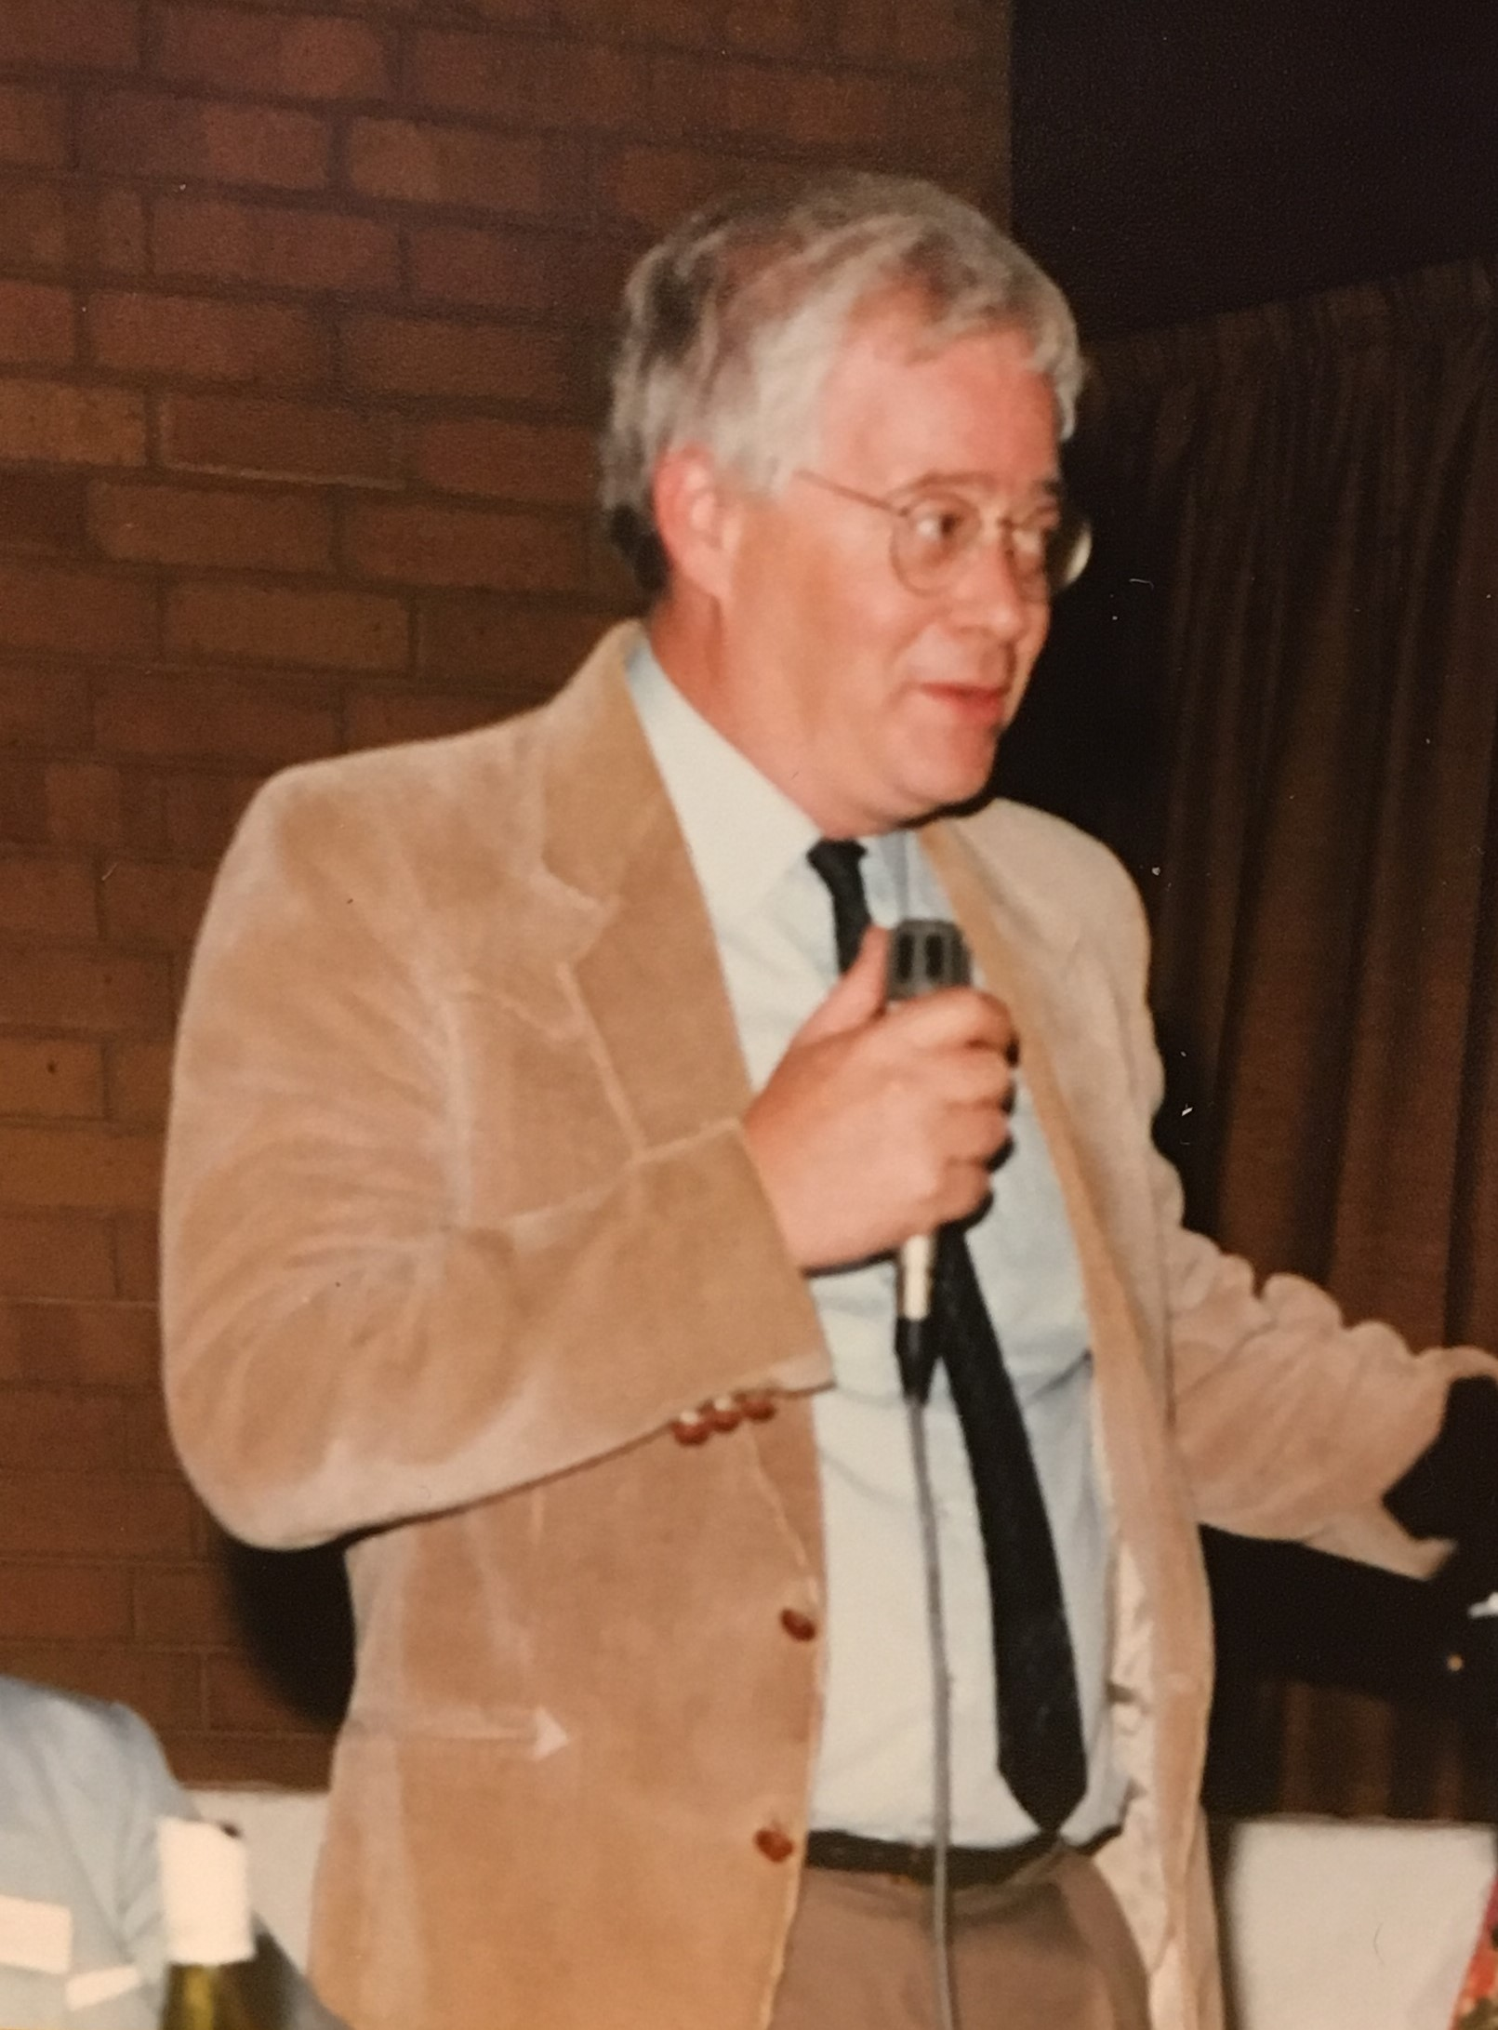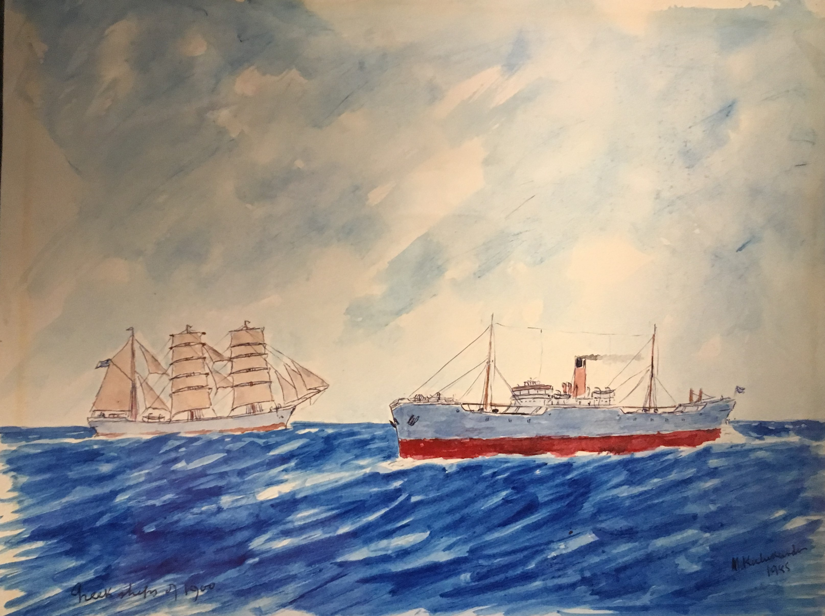
In memoriam Skip Fischer
25-26 April 2018
Institute for Mediterranean Studies-FORTH

What is Maritime History?
This symposium is to inaugurate the new Centre of Maritime History of the Institute for Mediterranean Studies and it is meant to bring together some of the members of the group of Maritime Historians that have marked the path of Maritime History in the last forty years. Professor Lewis R. (Skip) Fischer (1946-2018) was one of the “patriarchs” of Maritime History and paved the way of its organization worldwide since the 1980s. He had looked very much forward to this meeting but unfortunately he passed away on 11 February 2018. We have thus decided to dedicate this First Symposium to him, hoping to continue his work from this part of the world.
The Centre of Maritime History of the Institute for Mediterranean Studies of the Foundation of Research and Technology - Hellas is based in Rethymnon, Crete, Greece. The aim of the Centre is to expand research on a broad range of topics of Maritime History, related to the areas of the Mediterranean, the Black Sea and beyond, having the global, interdisciplinary and comparative studies in the epicenter. The Centre provides the necessary resources for young and experienced scholars to carry out their research in a stimulating and encouraging environment. Among these resources are: a) Digital data bases and archives, b) a specialized library, and c) a very cohesive and experienced group of researchers working in Maritime History. Furthermore, the Centre devotes funding resources to attract talented PhD students who are willing to pursue research on maritime history. The Centre aims to organize workshops, conferences and lectures in order to provide academic meetings at a regular basis and opportunities for scholars to discuss research problems and questions and exchange ideas for further research development.

PROGRAMME

Wednesday 25 April 2018

11:00- 13:00
1) Gelina Harlaftis, Director of the Institute for Mediterranean Studies, “Skip Fischer and the new Centre of Maritime History”
2) Malcolm Tull, President of the International Maritime History Association, “The role of the International Maritime History Association”

13:00-14:30 Lunch

14:30-16:30 Session I
Definition, thematics (topics)

1) Lars Scholl, Maritime History at Maritime Museums
2) Sarah Palmer, History of the Ports
3) Amelia Polonia, Inter-, multi- and trans-disciplinarity in Maritime History: Potentialities and Limits

Coffee Break

17:00-19:00 Session II
Global History and Maritime History. How much have we developed this? How comparative and transnational have we developed maritime history?

1) Gelina Harlaftis “Maritime History or History of the Sea”
2) David J. Starkey, "Why Maritime History?"
3) David Williams, Maritime History; Contexts and Perspectives

20:00 Dinner

Thursday 26 April 2018

10:30-12:30 Session III
Maritime History and other disciplines: parallel or interconnected lives? Interdisciplinarity in Maritime History

1) Μaria Fusaro, With what other disciplines does Maritime history communicate?
2) Stig Tenold, “Constantly crossing borders – research on maritime business”?

12:30-14:00 Lunch

14:00-16:00 Session IV
The Future in Maritime History: Research projects and continuity.

- Maria Fusaro, Early modern Maritime History in ERC projects
- Apostolos Delis, Modern Maritime History in ERC projects
- Katerina Galani and Alexandra Papadopoulou, National Research Projects in Maritime and Economic History

16:00-16:30 Coffee Break

16:30-18:00 Global Maritime History. Round Table and Conclusions

18:00 The Centre of Maritime History’s Ph.D. scholarship in Maritime History, Aegeus Foundation

20:00 Dinner

